 MHVBO PROFILE

**PERSONAL**

*MICHAEL BERNSTEIN*

*PO Box 909, 63 Lloyd Lane, Monticello NY 12738*

Email: Bernsteinms@hotmail.com

* + - * Home Phone: 845 794-0427
      * Cell Phone: 845 707-6622

**PROFESSIONAL**

*Career: Semi-Retired*

**VARSITY** *VB Memberships:*

*Since 2001 Other Memberships: Basketball*

**INTERESTS**

*Golf, Firefighter*

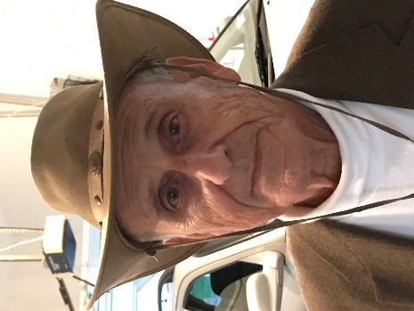 MHVBO PROFILE

**PERSONAL**

*VINCENT “VINCE” BITONTE*

*PO Box 87, 253 Bayard St. Port Ewen, NY 12466*

Email: Heyblue@hvc.rr.com

* + - * Home Phone: 845 338-9463
      * Cell Phone: 914 557-0226

**PROFESSIONAL**

*Career: Retired IBM, Armed Forces, Educator*

**VARSITY** *VB Memberships: PAVO State, NYSCVOA Varsity*

*Since 1976 Other Memberships: Baseball. Basketball*

**INTERESTS**

*Family, Golf. Traveling,Lifetime sports fan, NY Yankees, Giants, Rangers, Knicks*

 MHVBO PROFILE

**PERSONAL**

*HENRY “HANK” BOLDRIN*

*46 Lawrence Road Hyde Park NY 12538*

Email: [Hankjrref@gmail.com](mailto:Hankjrref@gmail.com) or [Held46@optonline.net](mailto:Held46@optonline.net)

* + - * Home Phone: 845 229-0904
      * Cell Phone: 845 702-2005

**PROFESSIONAL**

*Career: IBM Product Planner*

**VARSITY** *VB Memberships:*

*Since 1988 Other Memberships: Basketball, Lacrosse*

**INTERESTS**

*Books, Beach Chairs, Surf, Dinner with Friends*

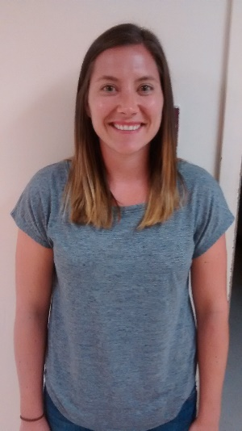 MHVBO PROFILE

**PERSONAL**

*CATHRYN BIORDI*

*1176 Washington Green, New Windsor NY 12553*

Email: [Cathryn.biordi@hffmcsd.org](mailto:Cathryn.biordi@hffmcsd.org)

* + - * Home Phone:
      * Cell Phone: 914 589-9676

**PROFESSIONAL**

*Career: HS Teacher (O’Neill*

**Junior VARSITY** *VB Memberships:*

*Since 2016 Other Memberships:*

**Inactive** **INTERESTS**



MHVBO PROFILE

**PERSONAL**

*THOMAS “TOM” BRADWAY*

*4 Kent Road Red Hook NY 12571*

Email: [Bradway](mailto:Bradway)16@gmail.com

* + - * Home Phone:
      * Cell Phone: 845 594-4079

**PROFESSIONAL**

*Career:*

**Junior VARSITY** *VB Memberships:*

*Since 2018 Other Memberships: Football. Basketball. Lacrosse*

**INTERESTS**

 MHVBO PROFILE

**PERSONAL**

*FREDERICK “FRED” BROOKS*

*10 Todd Drive Middletown NY 10941*

Email: frederickbrooks@hotmail.com

* + - * Home Phone:
      * Cell Phone: 646 261-7987

**PROFESSIONAL**

*Career:*

**MODIFIED**  *VB Memberships:*

*Since 2014 Other Memberships: Softball, Basketball*

**INTERESTS**

*Bowling*

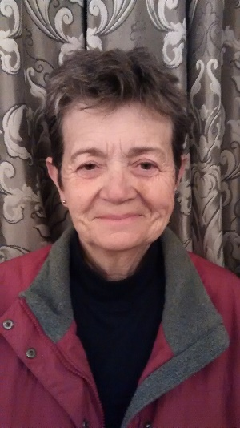 MHVBO PROFILE

**PERSONAL**

*CELESTE BRUNELL*

*PO Box 312 High Falls. NY 12440*

Email: [celeste.brunell@gmail.com](mailto:celeste.brunell@gmail.com)

* + - * Home Phone:
      * Cell Phone: 845 679-4357

**PROFESSIONAL**

*Career: IT*

**Junior VARSITY** *VB Memberships:*

*Since 2015 Other Memberships: Track*

**INTERESTS**

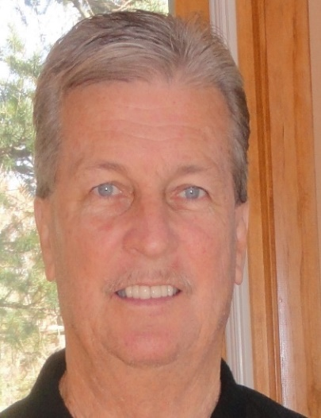 MHVBO PROFILE

**PERSONAL**

*GEORGE E COATES*

*46 Edinburgh Road Middletown NY 10941*

Email: [dellrocky@netscape.net](mailto:dellrocky@netscape.net)

* + - * Home Phone: 845 692-5662
      * Cell Phone: 646 265-0998

**PROFESSIONAL**

*Career: Teacher/Coach*

**VARSITY** *VB Memberships:*

*Since 1990 Other Memberships: Basketball*

**INTERESTS**

 MHVBO PROFILE

**PERSONAL**

*MARK B COLANDREA*

*61 Stewart Ave, Unit 115 Newburgh, NY 12550*

Email: [markcolandrea@hotmail.com](mailto:markcolandrea@hotmail.com)

* + - * Home Phone: 845 564-6152
      * Cell Phone: 845 542-0221

**PROFESSIONAL**

*Career: Construction*

**MODIFIED** *VB Memberships:*

*Since 2002 Other Memberships: Softball, Football, Basketball.Track*

**INTERESTS**

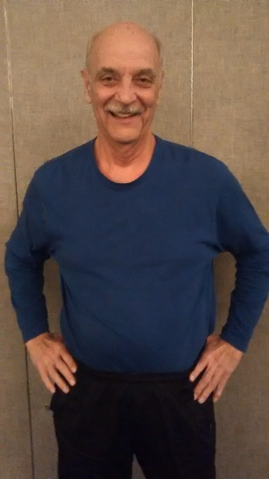 MHVBO PROFILE

**PERSONAL**

*JOHN “JACK” COOK*

*12 Howard Drive Middletown NY 10941*

Email: jcook8@hvc.rr.com

* + - * Home Phone: 845 692-5580
      * Cell Phone: 845 325-4266

**PROFESSIONAL**

*Career: Retired Pharmacist*

**MODIFIED** *VB Memberships:*

*Since 2010 Other Memberships: Basketball*

**INTERESTS**

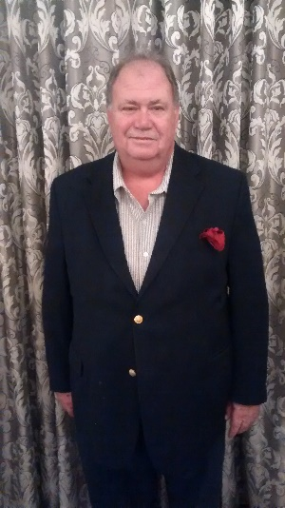 MHVBO PROFILE

**PERSONAL**

*JOE SHAWN COSGROVE*

*147 Clarke Road Goshen NY 10924*

Email: lcosgrov@warwick.net

* + - * Home Phone: 845 651-4023
      * Cell Phone: 845 649-1842

**PROFESSIONAL**

*Career:*

**MODIFIED** *VB Memberships:*

*Since 2019 Other Memberships: Softball and Baseball*

**INTERESTS**

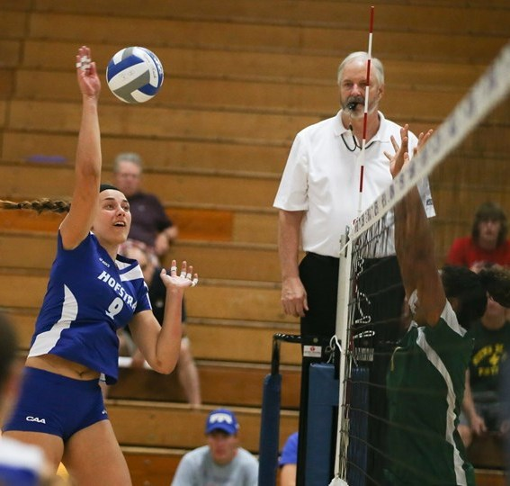 MHVBO PROFILE

**PERSONAL**

*TIMOTHY “TIM” COUNTRYMAN*

*2 Hudson View Drive Newburgh NY 12550*

Email: [trec153@aol.com](mailto:trec153@aol.com)

* + - * Home Phone:
      * Cell Phone: 845 527-8421

**PROFESSIONAL**

*Career: Real Estate Sales & Consulting, VB Officiating*

**VARSITY**  *VB Memberships: PAVO-National, USAV-National*

*Since 1987 Other Memberships:*

**INTERESTS**

*VB Lifer, Granddaughter. History & Museums, Cooking & Gardening, NY Yankees & MLB*

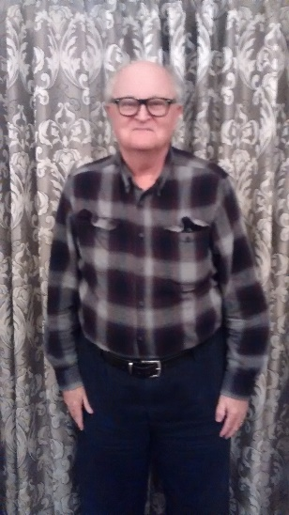 MHVBO PROFILE

**PERSONAL**

*JOHN DE CASTRO*

*9 Dwywr Lane Wappingers Falls NY 12590*

Email: bob100247@aol.com

* + - * Home Phone: 845 297-6989
      * Cell Phone:

**PROFESSIONAL**

*Career: Retired*

**MODIFIED** *VB Memberships:*

*Since 2019 Other Memberships: Football and Basebell*

**INTERESTS**

*Reading*

 MHVBO PROFILE

**PERSONAL**

*JOSE M DOMENECH*

*40 Addisson Road Fishkill NY 12524*

Email: bkb12524@hotmail.com

* + - * Home Phone:
      * Cell Phone: 917 334-8048

**PROFESSIONAL**

*Career: Business Owner – Medical Field*

**VARSITY** *VB Memberships: PAVO, USAVB*

*Since 2011 Other Memberships:*

**INTERESTS**

*Music, Sports, Helping others*

 MHVBO PROFILE

**PERSONAL**

*ROBERT JAMES ESSIGMAN*

*9 Dwywr Lane Wappingers Falls NY 12590*

Email: bob100247@aol.com

* + - * Home Phone: 845 297-6989
      * Cell Phone:

**PROFESSIONAL**

*Career: Retired*

**MODIFIED** *VB Memberships:*

*Since 2019 Other Memberships: Football and Basebell*

**INTERESTS**

*Reading*

 MHVBO PROFILE

**PERSONAL**

*MARVIN “MARV” W EVERSDYKE*

*118 Milford Estates Drive Milford PA 18337*

Email: [marvin_eversdyke@hotmail.com](mailto:marvin_eversdyke@hotmail.com)

* + - * Home Phone: 570 409-1723
      * Cell Phone: 570 872-2327

**PROFESSIONAL**

*Career: Director at Delaware Valley SD*

**Junior Varsity** *VB Memberships:*

*Since 2016 Other Memberships: Soccer, Lacrosse, Basketball*

**INTERESTS**

 MHVBO PROFILE

**PERSONAL**

*LYNN R FIELITZ*

*293 Rock Cut Road Walden NY 12586*

Email: lynn.fielitz@usma.edu

* + - * Home Phone: 845 566-1111
      * Cell Phone: 845 224-3000

**PROFESSIONAL**

*Career: Professor &. Assoc. Dir of Instruction at USMA*

**VARSITY** *VB Memberships: PAVO- State, USAV Regional*

*Since 2008 Other Memberships: Track & Field, Cross Country*

**INTERESTS**

 MHVBO PROFILE

**PERSONAL**

*JOSEPH “JOE” FORNERA*

*3 Harding Street Otisville, NY 10963*

Email: 1fornera77@gmail.com

* + - * Home Phone: 845 386-5352
      * Cell Phone: 845 551-1132

**PROFESSIONAL**

*Career: Retired Teacher*

**MODIFIED**  *VB Memberships:*

*Since 2014 Other Memberships: Soccer, Basketball*

**INTERESTS**

 MHVBO PROFILE

**PERSONAL**

*TOM FLYNN*

*37 Tanager Road Monroe NY 10950*

Email:

* + - * Home Phone:
      * Cell Phone: 915 568-5175

**PROFESSIONAL**

*Career:*

**Junior Varsity -Dual** *VB Memberships:*

*Since 2021 Other Memberships:*

**INTERESTS**

 MHVBO PROFILE

**PERSONAL**

*ROBERT GADSON*

*126 Upper PinekillRoad Westbrookville NY 12781*

Email: crazychris68@gmail.com

* + - * Home Phone:
      * Cell Phone:

**PROFESSIONAL**

*Career:*

**Modified**  *VB Memberships:*

*Since Other Memberships:*

**INTERESTS**

 MHVBO PROFILE

**PERSONAL**

*RICHARD “RICH” GAGNON*

*20 Greenvale Farms Road Poughkepsie NY 12603*

Email: willieg18@verizon.net

* + - * Home Phone: 845 452-4258
      * Cell Phone: 845 206-3122

**PROFESSIONAL**

*Career: Engineer*

**Junior VARSITY** *VB Memberships: PAVO- State, USAG Regional*

*Since 2016 Other Memberships: Umpire*

**INTERESTS**

*My Kids, Family, Golf*

 MHVBO PROFILE

**PERSONAL**

*THOMAS “THOM” GREAVEN*

*211 Grassy Ridge Road Olivebridge NY 12461*

Email: greav87@aol

* + - * Home Phone: 845 657-2937
      * Cell Phone: 845 559-3332

**PROFESSIONAL**

*Career:*

**MODIFIED** *VB Memberships:*

*Since Other Memberships:*

***Inactive*** **INTERESTS**

 MHVBO PROFILE

**PERSONAL**

*JERRY HAWKINS*

*50 Plymouth Avenue, Kingston NY 12401*

Email: Jnhawk7@yahoo.com

* + - * Home Phone: 845 338-4007
      * Cell Phone: 845 853-9872

**PROFESSIONAL**

*Career: Retired*

**MODIFIED**  *VB Memberships:*

*Since 2017 Other Memberships: Basketball, Softball*

**INTERESTS**

*Golf- Florida*

 MHVBO PROFILE

**PERSONAL**

*RODNEY CRAIG HENDERSON*

*8 Davis Street Rosendale NY 12472*

Email: rodro51@aol.com

* + - * Home Phone: 845 658-9180
      * Cell Phone: 845 514-6724

**PROFESSIONAL**

*Career: Carpenter*

**Junior VARSITY** *VB Memberships:*

*Since 1999 Other Memberships: Track, Softball*

**INTERESTS**

Reading, crossword puzzles

 MHVBO PROFILE

**PERSONAL**

*ROBERT “ROB’”HUMPHRIES*

*90 Autumn Chase Drive Hopewell Junction NY 12533*

Email: rhumphries@optimum.net

* + - * Home Phone:
      * Cell Phone: 845 728-377

**PROFESSIONAL**

*Career:*

**VARSITY** *VB Memberships:*

*Since 2018 Other Memberships:*

**INTERESTS**

 MHVBO PROFILE

**PERSONAL**

*JOSEPH “JOE” IZARRY*

*255 Scotchtown Road Goshen NY 10924*

Email: jirizarry1@hvc.rr.com

* + - * Home Phone: 845 294-7307
      * Cell Phone: 914 213-2366

**PROFESSIONAL**

*Career: Retired International VP of AIG*

**VARSITY**  *VB Memberships:*

*Since Other Memberships:*

**INTERESTS**

 MHVBO PROFILE

**PERSONAL**

*JOSEPH “JOE” JAMIN*

*40 Beale Road Cold Spring NY 10516*

Email: joejamin@optonline.net

* + - * Home Phone: 845 265-9051
      * Cell Phone: 845 661-1985

**PROFESSIONAL**

*Career: Finance*

**VARSITY** *VB Memberships: GEVA, PAVO, USAV*

*Since Other Memberships: Baseball*

**INTERESTS**

*Volleyball for the Deaf*

 MHVBO PROFILE

**PERSONAL**

*WAYMOND ISAACS*

*3 Alicia Drive Warwick NY 10990*

Email: waymondisaacs@gmail.com

* + - * Home Phone: 845 986-5312
      * Cell Phone: 718 614-7168

**PROFESSIONAL**

*Career:*

**MODIFIED**  *VB Memberships:*

*Since 2018 Other Memberships:*

**INTERESTS**

 MHVBO PROFILE

**PERSONAL**

*PETER KEBABJIAN*

*109 Old Unionville Road Wallkill NY 12589*

Email: [PeterKebabjian17@gmail.com](mailto:PeterKebabjian17@gmail.com)

* + - * Home Phone:
      * Cell Phone:

**PROFESSIONAL**

*Career:*

**Modified**  *VB Memberships:*

*Candidate Other Memberships:*

**2021 INTERESTS**

 MHVBO PROFILE

**PERSONAL**

*MIKE LATINO*

*6 Silo Ridge Drive Wallkill, NY 12589*

Email: MRL5482@aol.com

* + - * Home Phone: 845 883-0469
      * Cell Phone: 845 235-6339

**PROFESSIONAL**

*Career:*

**Junior VARSITY** *VB Memberships:*

*Since 2017 Other Memberships:*

**INTERESTS**

 MHVBO PROFILE

**PERSONAL**

*TONY “MAZ” MAZZELLA*

*PO BOX 198 Marlboro NY 12442*

Email: tonymaz56@hotmail.com

* + - * Home Phone:
      * Cell Phone: 845 430-2146

**PROFESSIONAL**

*Career:*

**MODIFIED** *VB Memberships:*

*Since Other Memberships:*

**INTERESTS**

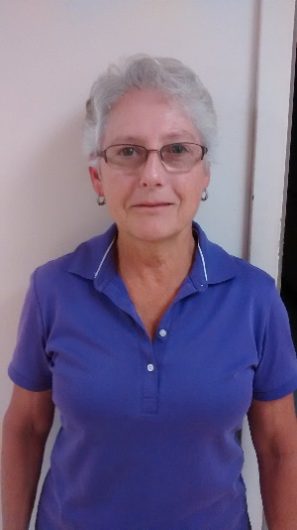 MHVBO PROFILE

**PERSONAL**

*LYNN McDONALD*

*611 South Hill Road Grahamsville NY 12740*

Email: lsmc7790@yahoo.com

* + - * Home Phone: 845 985-2916
      * Cell Phone: 914 799-4565

**PROFESSIONAL**

*Career: Financial Advisor*

**Junior VARSITY**  *VB Memberships:*

*Since 2009 Other Memberships: Track, Basketball*

**INTERESTS**

*Golf, Tennis, Pickelball*

 MHVBO PROFILE

**PERSONAL**

*JAMES PETER “JIM” McGUINNESS*

*203 County Route 17 Pine Bush NY 12566*

Email: [jim.mcguinnes@usma.edu](mailto:jim.mcguinnes@usma.edu) or jmcg2794@gmail.com

* + - * Work Phone: 845 938-3066
      * Cell Phone: 845 800-1971

**PROFESSIONAL**

*Career:*

**VARSITY**  *VB Memberships:*

*Since Other Memberships:*

**INTERESTS**

 MHVBO PROFILE

**PERSONAL**

*MICHAEL J “MIKE” MIGNOGNA*

*2202 Mulberry Court Poughkeepsie NY 12603*

Email: mickeymetric@aol.com

* + - * Home Phone: 845 473-9406
      * Cell Phone: 914 204-8575

**PROFESSIONAL**

*Career: Retired*

**VARSITY**  *VB Memberships:*

*Since 1996 Other Memberships:*

**INTERESTS**

*Golf, Listening to Music*

 MHVBO PROFILE

**PERSONAL**

*LAURIE A MUOLLO*

*16 Oak Drive Middletown NY 10940*

Email: laurie.muollo@cccsos.org

* + - * Home Phone: 845 342-4019
      * Cell Phone: 845 978-5433

**PROFESSIONAL**

*Career: Catholic Charities Comm Sus of Orange & Sullivan*

*Dir of Information Systems, Corporate Compliance Officer*

**VARSITY** *VB Memberships: IREVA ACVA, PAVO*

*Since 1998 Other Memberships:*

**INTERESTS**

 MHVBO PROFILE

**PERSONAL**

*HAROLD JAMES MURRAY*

*33 Jordan Lane Middletown NY 10940*

Email: mos217@aol.com

* + - * Home Phone: 845 394-0472
      * Cell Phone: 917 302-3258

**PROFESSIONAL**

*Career: Enterprise Rentals*

**MODIFIED**  *VB Memberships:*

*Since 2010 Other Memberships: Basketball*

**INTERESTS**

 MHVBO PROFILE

**PERSONAL**

*WILLIAM FRANCIS “BILL” NEWSOME*

*548 High Street Monroe NY 10950*

Email: wpnewsome@gmail.com

* + - * Home Phone: 845 782-7274
      * Cell Phone: 845 774-6053

**PROFESSIONAL**

*Career: Health & PE Teacher*

**VARSITY** *VB Memberships: NE Chapter 2 VB Officials New Jersey*

*Since 2016 Other Memberships: U.S.A. Club V.B.*

**INTERESTS**

Golf, Bike Riding, Swimming

 MHVBO PROFILE

**PERSONAL**

*CHRIS PANTANO*

*10 Mohawk Drive Wappingers Falls, NY 12590*

Email: Cmpantano@aol.com

* + - * Home Phone: 845 473-2355
      * Cell Phone: 845 905-9379

**PROFESSIONAL**

*Career: IT Manager*

**MODIFIED** *VB Memberships:*

*Since 2017 Other Memberships: Basketball, Lacrosse*

**Inactive** **INTERESTS**

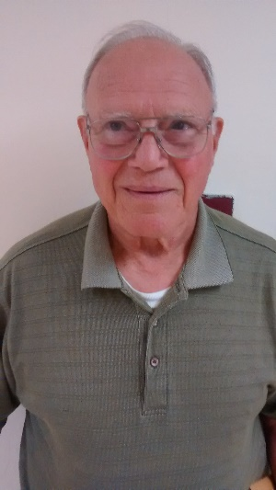 MHVBO PROFILE

**PERSONAL**

*PAUL PESAVENTO*

*18 Prentis Drive Hopewell Junction NY 12533*

Email: pipes@hvi.net

* + - * Home Phone: 845 221-5623
      * Cell Phone: 914 489-2114

**PROFESSIONAL**

*Career: Retired*

**MODIFIED**  *VB Memberships:*

*Since 2011 Other Memberships: Baseball*

**INTERESTS**

**Coins**

 MHVBO PROFILE

**PERSONAL**

*JOSEPH M “ JOE” POLETYNSKI*

*1 Trotting Drive Chester NY 10918*

Email: jpoletyn@optonline.net

* + - * Home Phone: 845 469-4734
      * Cell Phone:

**PROFESSIONAL**

*Career: Highway & Drainage Designer*

**Junior VARSITY** *VB Memberships:*

*Since 1984 Other Memberships: Swimming, Baseball*

**INTERESTS**

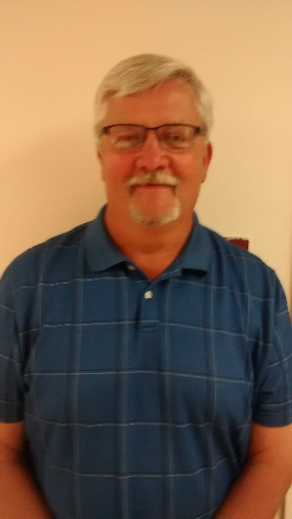 MHVBO PROFILE

**PERSONAL**

*THOMAS “TOM” POWERS*

*2 McKinley Place Beason NY 12508*

Email: tp77777@optimum.net

* + - * Home Phone: 845 440-3811
      * Cell Phone: 845 721-3597

**PROFESSIONAL**

*Career: Retired PE Teacher*

**VARSITY**  *VB Memberships: PAVO, NCAA*

*Since 1985 Other Memberships: Basketball*

**INTERESTS**

*Golf, All Sports*

MHVBO PROFILE

**PERSONAL**

*STEVEN REICH*

*37 Aldo Court Monroe NY 10950*

Email: SLR.ALLIED@live.com

* + - * Home Phone: 914 760-1781
      * Cell Phone:

**PROFESSIONAL**

*Career: Self Employed*

**MODIFIED**  *VB Memberships:*

*Since 2019 Other Memberships: Track & Field*

**INTERESTS**

Officiating & Refereeing

  MHVBO PROFILE

**PERSONAL**

*CASEY RUMSEY*

*1000 Scothtown Collaber Road Montgomery NY 12549*

Email: caseyrumsey@frontiernet.net

* + - * Home Phone: 845 361-4533
      * Cell Phone: 845 527-7899

**PROFESSIONAL**

*Career:*

**Junior VARSITY** *VB Memberships:*

*Since 2018 Other Memberships:*

**INTERESTS**

  MHVBO PROFILE

**PERSONAL**

*ANTHONY “TONY” SCADUTO*

*20 Lena Lane Newburgh NY*

Email: afscaduto@yahoo.com

* + - * Home Phone: 845 656-5317
      * Cell Phone: 845 234-8419

**PROFESSIONAL**

*Career: Retiired Engineer and Active Chemical Adjunct Professor*

**MODIFIED** *VB Memberships:*

*Since 2019 Other Memberships:*

**INTERESTS**

All Sports, travel, politics and business

 MHVBO PROFILE

**PERSONAL**

*MARK ALLAN SCOTT*

*36 Willow Avenue Cornwall NY 12518*

Email: qtrekman@aol.com

* + - * Home Phone: 845 534-1173
      * Cell Phone: 845 926-8727

**PROFESSIONAL**

*Career:*

**VARSITY** *VB Memberships:*

*Since 1985 Other Memberships:*

**INTERESTS**

 MHVBO PROFILE

**PERSONAL**

*JAMES “JIM” SKIVINGTON*

*40 Merriewold Lane South Monroe NY 10950*

Email: jimmysiv@yahoo.com

* + - * Home Phone:
      * Cell Phone: 646 208-1686

**PROFESSIONAL**

*Career:*

**Junior VARSITY** *VB Memberships:*

*Since 2010 Other Memberships:*

**INTERESTS**

 MHVBO PROFILE

**PERSONAL**

*JOHN SKIVINGTON*

*1 Warden Circle Newburgh NY 12550*

Email: jskivington@yahoo.com

* + - * Home Phone: 845 926-2487
      * Cell Phone: 845 926-2486

**PROFESSIONAL**

*Career:*

**MODIFIED** *VB Memberships:*

*Since 2018 Other Memberships:*

**Inactive** **INTERESTS**

MHVBO PROFILE

**PERSONAL**

*MARGARET MARY “BABS” STEAD*

*40 Second St. PO Box 994 Hilburn NY 10931*

Email: pegvb@aol.com

* + - * Home Phone: 845 357-3349
      * Cell Phone: 914 907-6916

**PROFESSIONAL**

*Career: Retired Teacher*

**VARSITY-Dual**  *VB Memberships: Rockland County*

*Since 2000 Other Memberships: Swimmimg, Track & Field*

**INTERESTS**

*Grandchildren. Sports, Friends*

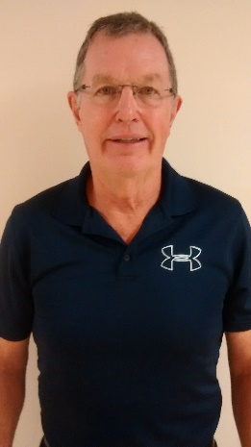 MHVBO PROFILE

**PERSONAL**

*JAMES “JIM” STEEVES*

*17 Fox Road Florida NY 10921*

Email: jamesmsteeves@gmail.com

* + - * Home Phone: 845 651-4955
      * Cell Phone: 845 536-1702

**PROFESSIONAL**

*Career: Retired PE Teacher*

**VARSITY**  *VB Memberships:*

*Since 1975 Other Memberships:*

**INTERESTS**

HS Basketball Coach

MHVBO PROFILE

 **PERSONAL**

*MARK CHARLES THATCHER*

*45 Weathervane Drive Apt #25 Washingtonville NY 10992*

Email: thatcher.game@gmail.com

* + - * Home Phone:
      * Cell Phone: 914 474-3325

**PROFESSIONAL**

*Career: Contractor*

**VARSITY**  *VB Memberships: PAVO, USAV (GEVA)*

*Since 2009 Other Memberships: A.S.A., E.C.S.U., P.O.N.Y., N.Y.S.S.O.*

**INTERESTS**

Golf, NY Mets, Constitutional Activism

MHVBO PROFILE

**PERSONAL**

*KAREN S THOMAS*

*4 Indiana Road Goshen NY 10924*

Email: kcthom@warwick.net

* + - * Home Phone: 845 651-7349
      * Cell Phone: 845 551-0080

**PROFESSIONAL**

*Career: Retired Recreation Therapist*

**Junior VARSITY**  *VB Memberships:*

*Since 2015 Other Memberships:*

**Inactive INTERESTS**

 MHVBO PROFILE

**PERSONAL**

*THERESA TRUJILLO*

*PO Box 906 Woodbridge NY 12789*

Email: trujilloone@gmail.com

* + - * Home Phone: 845 791-0866
      * Cell Phone: 845 791-0866

**PROFESSIONAL**

*Career: Education/Paralegal*

**MODIFIED**  *VB Memberships:*

*Since Other Memberships: Softball*

**INTERESTS**

MHVBO PROFILE

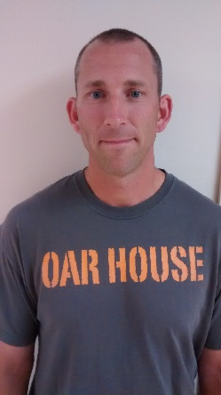**PERSONAL**

*DREW VAN DAM*

*40 Clara Ave New Windsor NY 12553*

Email: drew.vandam@usma.edu

* + - * Home Phone: 845 458-5132
      * Cell Phone: 845 522-9645

**PROFESSIONAL**

*Career: Instructor*

**VARSITY**  *VB Memberships: PAVO*

*Since 2013 Other Memberships: NATA, CSCS*

**Inactive INTERESTS**

*Golf*



MHVBO PROFILE

**PERSONAL**

*WAYNE VETRO*

*894 W. Kaisertown Road Montgomery NY 12549*

Email: wsvetro@gmail.com

* + - * Home Phone: 845 457-5125
      * Cell Phone: 914 443-7549

**PROFESSIONAL**

*Career: Operations Mgr. for Dana Distributors*

**VARSITY**  *VB Memberships: PAVO, USAV, GEVA*

*Since 2010 Other Memberships: Baseball, Basketball*

**INTERESTS**

Little League, Family Camping

MHVBO PROFILE

**PERSONAL**

*MARLENE B WAGNER*

*369 South Centerville Road Middletown NY 10940*

Email: partnerthinking@yahoo.com

* + - * Home Phone:
      * Cell Phone: 845 902-0544

**PROFESSIONAL**

*Career: Personal Business Coaching*

**Junior VARSITY**  *VB Memberships:*

*Since 1995 Other Memberships:*

**Inactive INTERESTS**

*Paddleboarding, alpine skiing, swimming, reading*

MHVBO PROFILE

**PERSONAL**

*JACOBI WARD*

*40 Maple Avenue Florida NY 10921*

Email: jacobi.ward20@gmail.com

* + - * Home Phone: 845 508-6217
      * Cell Phone: 917 601-5819

**PROFESSIONAL**

*Career: Law Enforcement*

**Junior VARSITY**  *VB Memberships:*

*Since 2019 Other Memberships: Basketball*

**INTERESTS**

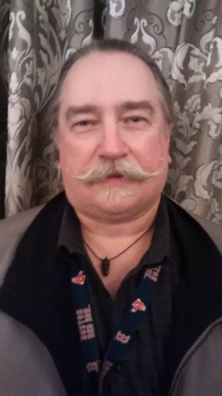 MHVBO PROFILE

**PERSONAL**

*JAMES L “JIM” WEGRZYN*

*129 Cedar Drive Kerhonkson NY 12446*

Email: jwegrzyn@earthlink.net

* + - * Home Phone: 845 687-3688
      * Cell Phone: 845 332-7338

**PROFESSIONAL**

*Career: Music Teacher, Performing Musician*

**Junior VARSITY**  *VB Memberships:*

*Since 2010 Other Memberships: Baseball*

**INTERESTS**

VB, Baseball, Music, Kids, Family Travel

MHVBO PROFILE

**PERSONAL**

*RICHARD M “RICH” WENDEL*

*381 Lakeside Road Newburgh NY 12550*

Email: rw32561@aol.com

* + - * Home Phone: 845 566-0284
      * Cell Phone: 845 527-3451

**PROFESSIONAL**

*Career: IBM*

**MODIFIED**  *VB Memberships:*

*Since 2009 Other Memberships: Basketball, Track & Field*

**INTERESTS**

*Golf, Traveling*

 MHVBO PROFILE

**PERSONAL**

*TOM WILSEY*

*4 Pasture Lane Poughkeepsie NY 12603*

Email: taw156@hotmail.com

* + - * Home Phone: 845 462-2842
      * Cell Phone:

**PROFESSIONAL**

*Career: Retired*

**VARSITY**  *VB Memberships:*

*Since 2007 Other Memberships: Basketball, Baseball, Track, Softball*

**INTERESTS**

MHVBO PROFILE

**PERSONAL**

*CHERYL A WILSON*

*22 Shaker Lane Hyde Park NY 12538*

Email: gymteach2@optonline.net

* + - * Home Phone: 845 229-7607
      * Cell Phone: 845 242-4085

**PROFESSIONAL**

*Career: Retired PE Teacher/Coach*

**VARSITY**  *VB Memberships: PAVO*

*Since 2013 Other Memberships: Gymnastics*

**INTERESTS**

*Golf, Traveling, Crafting*

MHVBO PROFILE

**PERSONAL**

*TONI WOODY*

*53 Van Alst Road Montgomery NY 12549*

Email: woodtc14@gmail.com

* + - * Home Phone: 845 457-4890
      * Cell Phone: 845 224-5464

**PROFESSIONAL**

*Career:*

**VARSITY**  *VB Memberships:*

*Since 2018 Other Memberships:*

**INTERESTS**