**The New York State Certified Volleyball Officials’ Association**

**Rules and Procedures Manual**

**2020-2021**

**Preface**

New York State Certified Volleyball Officials’ Organization (NYSCVOA) is responsible for providing volleyball officiating services to the New York State Public High School Athletic Association (NYSPHSAA) member schools. NYSCVOA and NYSPHSAA share a contractual agreement that outlines the conditions of the service NYSCVOA is to provide to the volleyball programs across New York State.

There are several committees that comprise the NYSPHSAA organization. Two committees recognized by NYSPHSAA are the Boys division and Girls division of volleyball section representatives. These committees directly impact the rules that NYSCVOA officials must enforce. Compilations of suggested “best practice” from these discussions are known as the *New York State Rule Modifications*. These modifications may differ slightly from NCAA rules, yet are of equal importance and must be implemented consistently throughout New York State.

ﻫ ﻫ ﻫ ﻫ ﻫ ﻫ

This manual was developed in part to act as a quick reference to the *New York State Rule Modifications* that have been approved by NYSPHSAA. The information contained herein is to be upheld and properly enforced during all NYSPHSAA interscholastic volleyball competitions.

This manual also contains match procedures and officiating techniques that have been adopted by the interpretation and exam committees of NYSCVOA. These NYSPHSAA approved practices will be consistently followed by every NYSCVOA official as all NYSPHSAA member schools are aware of and expect the official to conduct interscholastic volleyball contests according to these procedures.

ﻫ ﻫ ﻫ ﻫ ﻫ ﻫ

Officials needing a NYSCVOA or NCAA rule interpretation or clarification may contact their local board chair or board interpreter. The board chair or interpreter must consult the NYSCVOA rules interpreter for further assistance. Please refrain from contacting the NCAA secretary-rules editor directly as there may be a different interpretation or technique for high school play.

**Table of Contents**

Officiating Equipment (pages 4 and 5)

Professional Protocol (pages 5 and 6)

Ball Handling Directives (page 7)

NYSPHSAA Handbook and Committee Rulings (page 7)

New York State Approved Rules Modifications (pages 8 – 18)

NYSCVOA Scoring (pages 19 – 28)

NYSCVOA Libero Tracking (pages 29 and 30)

NYSCVOA Assignment Guidelines (page 32)

NYSCVOA Certification Requirements (page 33)

NYSCVOA Practical Rating Criteria and Options (pages 34 and 35)

NYSCVOA Official Transfer Form (page 36)

**NYSCVOA Officiating Equipment**

**Uniform – required items for any assigned NYSPHSAA contest**

Approved NYSCVOA shirt

Navy dress slacks

White socks

White sneakers

Whistle

Sanction cards

Coin

**Optional Items**

Black or navy belt

Approved NYSCVOA wind jacket

Approved NYSCVOA sweater

Navy dress shorts may be worn per NYSCVOA Constitution and By-Laws.

(Check local board policy as shorts may not be permissible)

Electronic whistle

**For post-season play it is important for the official teams to match.**

**The first referee and second referee must match.**

**The 2 or 4 lines judges must match.**

**All uniform options must be available on site for all post-season play assignments. The (committee) selected official is responsible to bring all**

**approved uniform options.**

**Certified officials must refrain from wearing excessive jewelry.**

**Once the match officials are courtside, only approved NYSCVOA apparel is acceptable.**

**Cell phones and other devices are not part of the official uniform and should not be worn or used during a match.**

**NYSCVOA officials should have the following courtside:**

* + **NYSCVOA Rules and Procedures Manual**
  + **NCAA Rules and Interpretation Book**
* **A device to measure the net height**
* **A device to check the ball pressure**
* **A device to modify the ball pressure**
* **A watch or time piece (not a cell phone, tablet, pad, etc.…)**
* **A blue, black or white whistle/electronic whistle on a blue, black or white lanyard**

**\*A pink whistle and/or lanyard may be worn for dig**

**pink events**

* **Flags for the lines judges (optional)**
* **Line up forms, NYSCVOA scoresheets and Libero Tracking sheets (optional)**

**Professional Protocol**

**Prior to the start of any Volleyball contest, locate the site supervisor or event manager. Crowd control will be the responsibility of the site supervisor or event manager. If there is no manager or supervisor available, crowd control rests with the home/host coach.**

* Upon arrival at the host site, introduce yourself to the host coach and obtain

any additional information necessary to conduct the match (e.g. national

anthem, senior night, playing all three JV sets, etc.…)

* After the team representatives’ meeting, introduce yourself to the coach of the

visiting team and relay all pertinent information received from the host coach

and include the results of the coin toss.

* There are two options for the coin toss procedure: have the visiting team representative call the coin while it is in the air, or call the coin prior to the toss.
* Always confirm the call with the other official or the opponent’s team representative.

**No official will address a spectator. Contact site supervisor/coach.**

**Limit court side discussions with coaches and athletes. Avoid the appearance of favoritism or bias.**

**Refrain from physical contact with the athletes during set/match procedures.**

**The first referee (R1) will remain on the stand for the duration of the match. Refer to NCAA rule book for unusual situations when the R1 may vacate the stand.**

**NYSCVOA officials should refrain from commenting on any social media and networking site(s). Comments or pictures that potentially could result in harm or the perception of bias should be avoided both on and off the court.**

**NYSCVOA officials do not promote items associated with volleyball vendors, bidders or contracts for merchandise. Officials will not promote a specific company or item.**

**The officials should arrive and leave the playing site together. NYSCVOA officials should not participate in post-match discussion with coaches, spectators, media or team personnel.**

**Prompt departure from the court area is strongly encouraged.**

**The procedure (below) is strongly recommended for all contests as it requires the officials to remain together after completion of the match and until they leave the playing area.**

* The R1 will exit the ladder to the right once the signal has been given for the

teams to meet at the net and shake hands.

* The R1 will proceed to the center of the end line (on the right).
* The second referee (R2) will proceed to the same area as the R1, thus exiting

to the left side of the court.

* The line judge on the R1’s side of the court will join the R2 and R1 at the end

line. The line judge on the R2’s side of court will meet the other three officials at the score table and all will exit the playing area together.

* The exit strategy (gathering belongings, etc.…) needs to be discussed amongst

all the officials prior to the start of the contest.

**The NYSPHSAA State Tournament uses this end of match protocol for all championship matches.**

**Ball Handling Guidelines**

Ball handling is a topic of conversation at every committee meeting. The guidelines are as follows:

* Consistency is paramount. When a decision is made and a ball handling error whistled, the official should have the ability to whistle that same contact for the duration of the contest.
* Successive or multiple contacts are legal during blocking or the team’s first contact. A caught or throw ball or prolonged contact is a fault.
* Over control of the ball will usually result in a caught or thrown ball fault being whistled
* Under control of the ball will usually result in a double hit fault being whistled
* Judge the point of contact only. Do not take consider the player’s body position or “athletic ability” when judging ball handling.
* Do not base ball handling decisions on the spin of the ball, spectator or participant reaction.
* Exigent or great plays should be judged less severely. Blatant faults should always be whistled.
* A poor ball handling decision (e.g., taking the ball with hands instead of passing it with forearms) doesn’t necessarily equal a spectacular or great play.

**NYSPHSAA Handbook and Committee Rulings**

No High School student (or younger) is allowed to wear jewelry while on the playing surface. Sneakers will be worn by line judges and any participant that is on the playing surface.

A NYSPHSAA waiver is necessary for equipment worn by a student athlete beyond the scope of the NCAA rules book. Check local section policy.

The sportsmanship card must be read at every contest. The sportsmanship card must be read at all post-season matches.

Spectator participation is allowed during competition. There is no approved modification or rule that supports being quiet during execution of the serve.

Actions NOT allowed by spectators are: calling out the athlete’s name, number or making racial, religious, sexual or derogatory comments.

Throwing objects and artificial noise makers are not allowed. Check local section policy.

**New York State Approved Rules Modifications**

**Rule 1: Facilities and Equipment**

The playing court may have end lines and sidelines that are interrupted.

Attack line extensions are not required to play a match.

The referee stand and platform may or may not be distributed evenly behind the pole. The ladder may or may not be distributed evenly at the back of the referee platform.

**Rule 2: The Net and Related Equipment**

The net height for NYSPHSAA interscholastic men’s competition will be 7 feet 11 5/8 inches

The net height for both men’s and women’s competition must measure correctly at the center. The two ends of the net must measure the same and should not be more than ¾ inch higher than the center of the net.

**Rule 5: Teams**

If a coach is not available, the playing captain may NOT assume the duties and responsibilities of a coach.

**Rule 6: Individual and Team Sanctions**

Check local section policy for sanction guidelines. If no such policy exists, the NCAA rule is in effect.

* Officials are often unsure when to sanction a coach, athlete or other match

participant. One recommendation is when the person is distracting the

attention of an official away from match duties, it is time for a sanction.

* When the first referee assesses a sanction, the proper procedure is to whistle, display appropriate card on correct side of the net, and notify the floor captain. The second referee will notify the coach and scorer.

Officials will not remove a disqualified team member from the playing surface, bench or spectator areas. Sanctions will be assessed to the head coach for any further disruptions caused by a disqualified player.

**Rule 7: Players’ Equipment**

An individual may have a different number when changing from a regular team uniform jersey to a libero jersey.

A libero jersey may not be passed among teammates.

Neoprene sleeves are not considered part of the uniform and may be multiple colors. Neoprene sleeves are considered necessary personal equipment.

Jewelry is not permitted at any time including the warm-up period. This includes “non-visible” jewelry (i.e. body jewelry, ear gauges, and tongue studs). Bobby pins, hair ties worn on the wrist and string bracelets are considered jewelry. Taping jewelry is not permitted at any time.

* A player wearing visible jewelry should be asked politely to remove it. Prompt removal of jewelry is required.
* A player with taped (alleged) jewelry should be questioned in the presence of the head coach.
* A player on the court with jewelry will result in a team delay sanction, only if the removal causes a delay in the game. Prompt removal of jewelry is required.

The only type barrette that is legal is a “flexible” barrette.

Feathers or extensions worn in the hair must be legally secured.

Hard plastic headbands are not legal.

Spacers/gauges worn in the ear or lobes are not legal.

Contact local Chapter/Board Rules Interpreter if questions arise regarding the legality of players’ equipment beyond the scope of the NCAA rules. A NYSPHSAA waiver may be required.

An administrative red card will be issued when all team members are in illegal uniforms.

Illegal uniform issues will be handled following the steps below. The libero uniform is exempt from this modification. This modification is intended to provide an avenue for a student athlete to participate when a legal uniform is not available.

* Notify the coach of the team at fault to determine whether the uniform can be brought into compliance. The coach will legalize the uniform for the team member.
* If the uniform cannot be legalized, discuss with the opposing coach to determine whether a protest will be filed.
* If no protest is filed at the time of the discussion, no future protest will be accepted in regards to uniform compliance.
* If the coach wishes to protest, record the events per the rule book. Play the match and file the proper paperwork regarding the protest. Check local board

policy.

**Rule 8: Scoring and Duration of Matches**

For women varsity, women junior varsity and men junior varsity competition: All sets of a match are 25 points. A team must win by two. No point cap is in effect for any set.

Teams will switch sides when one team reaches 13 points in the 25 point deciding set.

**Rule 9: Protocols**

Electronic whistle (optional)

* + Choose an appropriate sound
  + The whistle should be on a long lanyard. The whistle should be waist/belt height.
  + To begin a rally hold the whistle in the hand on the receiving team’s side of the net. Sound the whistle and then beckon for serve.
  + During the rally, if more comfortable, change the whistle to your dominant hand. Make the transfer discreetly.
  + To end a rally/set/match, sound the whistle, release the whistle and follow appropriate signal sequence for the situation.

Meet with the team representatives for ground rules and coin toss. The clock for the warm-up period will not begin until the team representatives are released. Check local board policy for the total time to be set on the clock. There is no hitting or serving during shared court time.

Girls’ protocol: set clock 23 minutes: Boys’ protocol: set clock 25 minutes

23-19 minutes shared court 25-20 minutes shared court

19-15 **4** minutes visitors court 20-15 **5** minutes visitors court

15-11 **4** minutes home court 15-10 **5** minutes home court

11-6 **5** minutes visitors court 10-5 **5** minutes visitor court

6-1 **5** minutes home court 5-0 **5** minutes home court

1. **see below **no** whistle/horn

Warning whistles are blown at 15 seconds for each segment of time. The horn will terminate each segment (exception: The final minute for girls will have no warning whistle or horn).

**\*\*The Final Minute of the Girls’ Pre-match Warm-up**

* After completion of the timed pre-match warm-up and the court is made ready for play, team introductions and the national anthem will commence immediately. The one minute remaining on the clock will begin after the national anthem and team introductions. If there are no team introductions and/or national anthem the one minute on the clock will start after the court is made ready for play. In both situations the teams have one minute to get the starters on the end line and for play to begin after the court has been cleared.

The clock will run **continuously** stopping only for injury, safety issues, equipment failure or as stated above (girls’ pre-match warm-up).

The team that does not have exclusive use of the court will be allowed to warm-up as long as they remain 2 meters away from the court boundaries and do not interfere with the team that has exclusive use of the court.

**Rule 10: Team Lineup and Rotation Order**

The coach must initial the first set of the lineup sheet. Coaches must be designated on the lineup sheet for the first set of the match.

Officials are not required to check team rosters or player eligibility.

The second referee will indicate the captain with an open hand. The captain will acknowledge the first referee and the first referee will acknowledge the captain in a professional manner. If the captain changes, the second referee will indicate the replacement captain upon entering the court using the procedure above.

**Rule 11: Game Interruptions**

The length of all timeouts in a match will be 60 seconds.

* The second referee will notify the coach when the second timeout has been issued for the set. Do not use NCAA signal 14 (timeout) when relaying the information.
* After the timeout request is acknowledged, the second referee will signal to the first referee the number of timeouts charged to each team.
* The second referee will blow a warning whistle 15 seconds prior to the end of the timeout. Instruct the scoreboard operator to sound a horn at the end.
* If the timeout ends prior to the 15 second warning whistle, the second referee will blow a warning whistle when both teams are on the court ready to play followed by the horn to end the timeout. Ensure the clock is stopped to avoid an inadvertent horn during play.
* After the timeout, the second referee will indicate the number taken by each team to all match participants. Release the court to the first referee using the release of court signal.

The number of team substitutions in a set is 18. The procedure for authorizing a substitution is as follows:

* After the substitution request is acknowledged, the second referee will

step back towards the score table in such a manner as to allow the

scorer to visualize the players entering and leaving the court. The

second referee should remain square to the court during this procedure.

* The second referee will relay the numbers to the scorer, stating the

player’s number entering the court followed by the player leaving.

* After authorization for entry, the second referee will ensure the scorer is

ready to resume play, scan both benches for additional requests, assume

the base position for the next rally, and then releases the court using the

release of court signal.

* The first referee will mimic the second referee’s substitution signal

without whistling

When a substitution is whistled prematurely (no request made by a coach or playing captain) by the second referee, the proper procedure is as follows:

* The second referee will touch palm to center of chest and then release the court to the first referee using the release of court signal (palm faces net). (Slide 31 on the NYSCVOA website)

The second referee will notify the first referee upon completion of the eighteenth team substitution.

The second referee will notify the coach when the fifteenth through eighteenth team substitutions are used. The coach may not protest if the information is not provided.

* Do not use NCAA signal 15 (substitution) when relaying this information to the coach or first referee.

Distinct whistles are used when acknowledging and granting a legal game interruption. For instance 2 short whistle blasts for substitution and

timeout. Several short whistle blasts for a player/court safety issue.

**Rule 12: Boy’s Only – The 2 Libero System**

If a team is going to use 2 liberos, the team must designate 2 liberos on the first set of the lineup sheet.

* When the lineup sheet allows for 2 liberos and only one libero is noted by the coach, an ‘X’ is necessary on the second libero line. If the ‘X’ is not recorded, double check with the coach. If no second libero is designated by the coach, place an X on the second libero line on the lineup sheet.

The team can only use those two designated players as liberos for the entire match.

Only one libero can serve during the set.

Only one libero may be on the court at any time

* The replacement player may replace and be replaced by either libero.
* The acting libero can only be replaced by the player whom he replaced (for that position) or
* By the second libero.

The libero may be designated as a captain.

If one libero cannot continue to play due to injury or illness the team will play the rest of the match with one libero.

If the remaining libero cannot continue to play due to injury or illness the libero may be replaced (follow NCAA rules for libero replacement).

If one libero is disqualified due to unsportsmanlike behavior the team will continue the set without a libero.

* The second libero may be used in the subsequent sets.

Teams will follow the NCAA rules when using one libero.

**Rule 15: Boy’s Only – Play at the Net**

The center line rule for all NYSPHSAA Boy’s interscholastic competition is as follows:

* To touch the opponent’s court with a foot (feet) or hand(s) is permitted, provided that some part of the penetrating foot (feet) or hand(s) remains either in contact with or directly above the center line.
* To contact the opponent’s court with any other part of the body a fault.
* A player may enter the opponent’s court after the ball goes out of play.

**Rule 18: Challenge Review System**

The rule will not be used.

**Rule 19: Officials and Their Duties**

Officials should arrive 30 minutes before the start of the match for regular season play. Officials are requested to arrive 40 minutes before match time for post-season play. Check section policy.

* Discuss exit strategy for when the match is completed.
* Locate the site supervisor for potential match/crowd issues.
* Introduce yourself to the score table crew and lines judges and instruct

them accordingly, using concrete examples of various set situations.

* Monitor warm-up activities court side near the score table.
* Monitor player safety and ensure proper protocol is being

followed during the warm-up period.

* Discuss ball handling parameters, sanction requests and any other potential match situations.
* Identify the setters and primary passers for the teams involved and discuss with partner potential violations in rotation order (overlaps).
* The second referee will conduct the deciding game coin toss. If a team selects the other side of the court, the second referee communicated this to the first referee. The first referee will whistle and give the change of courts signal. The three minute clock starts with the first referee’s whistle.
* If the teams select the current side, the first referee will whistle and signal teams to the benches. The three minute clock starts with the first referee’s whistle.
* The first referee will whistle and give the change of court signal for all non deciding sets played in a match.
* When the first referee assesses a sanction, it must be accompanied by a whistle. See rule six, sanctions.

Once the match officials are courtside, only approved NYSCVOA apparel is acceptable.

The match officials **do not** adjust equipment. Notify the host coach or site supervisor for any necessary modifications to the playing equipment/area.

The second referee (R2) will use the lineup sheets submitted by the teams to verify the players’ numbers are correctly recorded on the score sheet. The R2 will communicate with the scorer and verify players’ positions on the court prior to each set. A libero replacement cannot be made until the starting players are verified.

* The R2 will read the numbers of the players on the court to the scorer while standing near the score table or
* The scorer will read the numbers of the players on the scoresheet to the R2 while standing near the score table.

The lineup sheets, once submitted and recorded, are to remain at the score table for the duration of each set.

The lineup sheet must be signed / initialed by the coach for the first set of the match. It is not required for sets two through five.

Once play has begun, the score sheet must be used for all lineup check requests by coaches or captains. A lineup check is a courtesy and is not considered a legal game interruption. However, careful review of the players’ positions in reference to the score sheet is paramount. When a lineup check is requested, take the time to get the players in correct service order on the court.

When a fault is whistled by the second referee (R2):

* + Whistle the fault, move to the fault side of the net, indicate the nature of the fault and the player’s number (if necessary) to the first referee.
  + The first referee indicates the result of the play (point or replay) and then repeats the player’s number to the bench (when applicable). The player’s number is displayed with elbows at chin height and the first referee is square to the court. Numbers one through five and number ten are displayed using the hand on the side of the fault. Numbers requiring two hands are displayed square to the court, elbows are at chin height.
  + The second referee waits to mimic the result of the play signal made by the first referee (replay or point).

Center line faults do not require a player number unless requested by the coach.

When the first referee whistles to stop play, it is not necessary for the second referee to move to the fault side of the net although in some situations, moving to the fault side of the net enhances communication to the first referee. At the end of a rally, it is required to be fully visible to the first referee and have the body square to the court.

The second referee will use the release of court signal (slide 24) to begin the set and after any game interruptions (timeout, substitution). It may also be used after a long delay due to a score issue or for other prolonged delays.

* The release of court signal is the outside net hand perpendicular to the

floor, raised shoulder height with the thumb and fingers together.

* The release of court signal is not to be used after every rally.

The first referee will whistle warning whistles (for timeout or interval between sets) for the second referee when the second referee is occupied and unable to do so.

The head coach will be notified when the 15th, 16th, 17th and 18th team substitutions are taken.

* The second referee will indicate the number of team substitutions taken to the coach. Do not use signal 15 (substitution) when relaying this information to the coach.
* Do not chase the coach to relay team substitution information as it delays resumption of the match.
* The second referee will indicate when the 18th team substitution has been used to the first referee. It is not necessary to use NCAA signal 15 (substitution) when relaying this information to the first referee.
* After scanning the benches and getting in base position for the next rally, with body squared to court and whistle in mouth, the second referee will release the court to the first referee by using the release of court signal.

The head coach will be notified when the second team timeout has been taken.

* The second referee will notify the coach when the second timeout has been issued for the set. Do not use signal 14 (timeout) when relaying this information.

The second referee will use NCAA signal 13a (end of set or match) when appropriate.

The second referee will **not** indicate number of sets won to the first referee.

The Assistant Scorer (Libero Tracker) will use the NYSCVOA Libero Tracking Sheet for monitoring all substitutions and libero replacements. The tracker will assist the scorer as necessary. If a team does not use a libero player, the Assistant Scorer must keep track of team substitutions on the Libero Tracking Sheet.

The Scorer or Libero Tracker will verbally verify to the second referee the status (on or off the court) of each team’s libero during a timeout.

The visiting team may provide a scorer and assistant scorer. They will be allowed to sit at the score table. The home team’s score book will be the official match record.

The second referee will work in conjunction with the host/home scorer. It is not necessary to hold substitutions until the scorer has completely recorded the players’ numbers. The player(s) can be authorized for entry while the scorer records the substitution. Do not release the court until the scorer is ready.

The scorebook should be checked during timeouts to ensure all information is recorded correctly.

Referees can make corrections to the scoresheet/score when the first or second referee is able to reconstruct the events that took place.

A protest must be requested by a coach or captain if the first and second referee is to use any other match information from statisticians, visiting score book, coaches, etc., (NCAA Rule 17.2.2.5) in regards to correcting any errors to the official (home) scoresheet/score.

**Scoring**

**The Lineup Sheets**

The scorer writes the players’ uniform numbers in serving order in the PLAYERS’ NUMBERS section of the scoresheet. The scorer will start with position one (right back player) for the serving team. The numbers are recorded counterclockwise. The receiving team will start with position two (right front player).

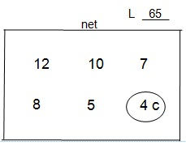 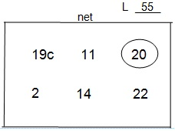

*B. Barry* *G. May*

The circle on the lineup sheet indicates first server for the team. This is optional information provided by the coach. A captain (denoted by a **c**) and the coach’s initials/signature, on the first set, are required for a legal lineup.

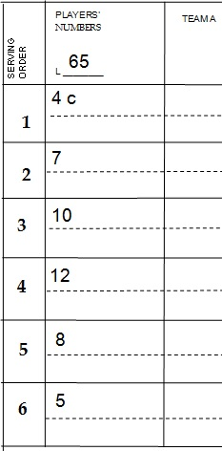 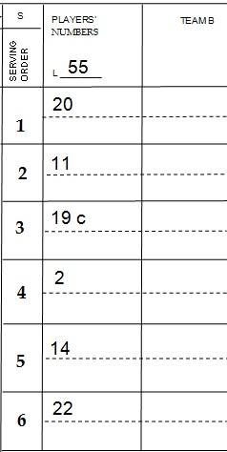

Team A’s representatives won the coin toss and chose to serve. Circle the S on Team A’s side of the scoresheet. Team A will be on the scorer’s left and Team B on the right.

C:\Users\Salpen\Desktop\first serve.jpg

**The Language and Symbols**

The term ‘scoring section’ is the space where serves, substitutions and important

match information is recorded. The horizontal lines are noted with numbers 1-6.

The term ‘running score column’ refers to the vertical score column in the center

of the scoresheet.

When a non-libero player serves, a circle is used on the line of the server in the scoring section.

When a libero player serves, a triangle is used on the line of the server in the scoring section.

In the scoring section, the items that are written inside a circle or triangle are: a **point number**, the letter **P** (play-over) or the letter R (rotate).

The circle/triangle is drawn on the server’s line in the scoring section after the ball is contacted for service.

A rally won by the serving team: Record the **point number** in the server’s circle/triangle

and draw a circle/triangle around the corresponding point in the serving team’s running score column.

A rally won by the receiving team: Record the letter **R** in the server’s circle/triangle and slash the next point in the receiving team’s running score column. The corresponding point is also recorded on the line of the receiving team’s next server. There is no symbol drawn around the slashed points when recorded in the scoring section.

When a rally is replayed (play-over), record a **P** in the circle/triangle on the server’s line of the scoring section. Nothing gets recorded in the running score column.

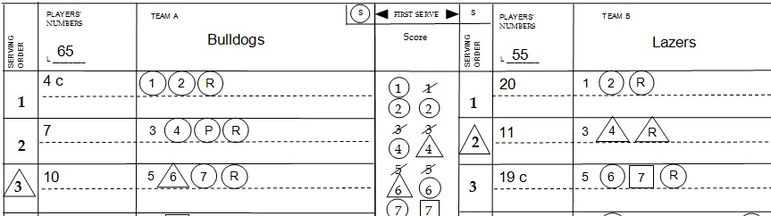

When a libero player serves, a triangle is used in the scoring section. Points scored in the running score column are marked with a triangle. The first time the libero serves in a set, a triangle is placed around the number on the line where the libero served.

A square used in the scoring section indicates a no serve situation (mind change, incorrect server, penalty sanction or disqualification). The **point number** or **R** is recorded in the square. A square would be placed around the appropriate point in the running score column for the team that was awarded the point. The only time a square is used in the running score column is when a point has been awarded because of a penalty.

Team A # 8 received a red card penalty. Team A’s score at the time of the penalty was seven. Team B’s score at the time of the penalty was six. The square around the seven in the running score column is the point awarded for the penalty. In the scoring section the squared seven represents a no serve situation and is the point awarded for the penalty.

Team B

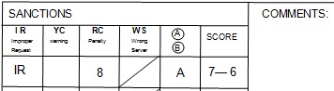 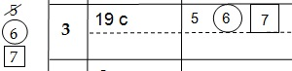

When a rally is stopped and a red card penalty is issued, the scorer will draw a square around the circle/triangle and record the appropriate symbol in the scoring section of the scoresheet.

The serving team’s non-libero player receives a red card penalty during a rally. In the scoring section place a square around the circle and an **R** inside. The next point for the receiving team is squared in the running score column on the receiving side. The corresponding number is recorded on the next server’s line with no symbol.

The circle in the square is replaced by a triangle when the libero serves.

Serving team Receiving team

C:\Users\Salpen\Desktop\sancralyservteam.jpg

The receiving team’s non-libero player receives a red card penalty during a rally. In the scoring section place a square around the circle and record the **point number** inside. Draw a square around the corresponding number in the running score column.

The circle in the square is replaced by a triangle when the libero serves.

Serving team Receiving team

C:\Users\Salpen\Desktop\sancrallyserv.jpg

A referee’s mind change is noted with the letter **M** which indicates a decision change after the scorer has recorded the results of a rally. The letter **M** in the running score column is circled, triangle or slashed if the point is scored.

Serving team Receiving team

C:\Users\Salpen\Desktop\mindch.jpg

When the scorer makes an error in the scoring section, the error is crossed out and the appropriate symbol/number will be recorded. In the running score column, incorrectly recorded information will be crossed out and number(s) are rewritten. When the point(s) are recovered, use the appropriate symbol on the rewritten number(s) in the running score column.

Serving Receiving

C:\Users\Salpen\Desktop\scoerror.jpg

Points that are canceled because of a referee’s action are handled in the same manner as scorer’s errors. A referee may remove points as a result of a wrong server or an illegal player entry. A comment must be made in the COMMENTS section when points are removed as a result of an official’s action.

A player’s uniform that is damaged or saturated with blood is handled in the following manner. Cross out the damaged uniform number in the PLAYERS’ NUMBER column on the scoresheet and record the new number next to it. Record the reason for the number change in the COMMENTS section of the scoresheet, the team name and the score at the time the uniform was changed. The score of the team involved is recorded first.

A delay in service or the wrong server will result in the serving team losing the rally. The scorer records an **R** in a square for both situations in the scoring section of the scoresheet. The next point is slashed in the receiving team’s running score column and the corresponding number is recorded on the next server’s line in the scoring section with no symbol.

Serving Receiving

C:\Users\Salpen\Desktop\wrongserv.jpg

The wrong server is recorded the same way in the scoring and running score column as a delay in service. In addition, a wrong server requires documentation in the WS column of the SANCTIONS section of the scoresheet.

Team A’s #8 (incorrect server) served instead of #12 (the correct server). Team A’s score

was eight and Team B’s score was seven when Team A served out of rotation.

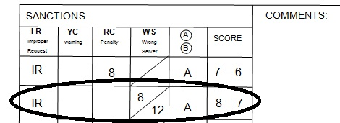

Team A’s #12 did not serve so an **R** is recorded in a square in the scoring section on number twelve’s line. For the receiving team, record like a delay (loss) of service.

Team A Team B

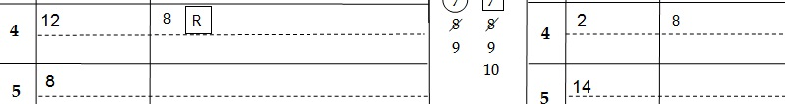

The **COMMENTS** section of the scoresheet is used when a situation cannot be recorded in the SANCTIONS section such as a change in uniform number or an exceptional substitution. The information in the COMMENTS section should include: the score at the time of the incident, official’s action, team involved and uniform number(s) of player(s) involved. When recording the team scores, the team involved in the incident is recorded first.

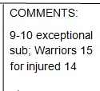

**Substitutions** (not exceptional substitutions) are recorded on the scoresheet in three places: the scoring section (on the current server’s line), the PLAYERS’ NUMBERS column and the SUBSTITUTIONS area below the scoring section.

Team B (currently serving) substitutes (S) player number 20 (entering the set) for player number 15 (leaving the set). The server is Team B’s #2 and the substitution is recorded on the current server’s line.

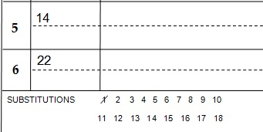 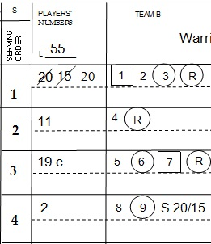

Team A (currently receiving) substitutes (Sx) player number 16 (entering the set) for player number 12 (leaving the set). The server is Team B’s #2 and the substitution is recorded on the current server’s line.

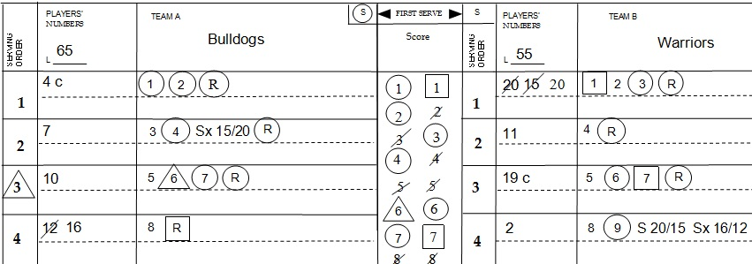



The first time the Warrior’s #20 left the set. Bulldogs #7 was serving and the score was

3 – 4 (Warriors – Bulldogs)

Sx = receiving team

15 player entering set over

20 player leaving set

Record **exceptional substitutions** by circling the number of the player being replaced in the PLAYERS’ NUMBERS column. Circle the substitution recorded on the server’s line (Team A#8 is currently serving). This indicates the player **cannot** return for the remainder of the set. Exceptional substitutions do not count toward team substitutions and are not counted in the SUBSTITUTIONS section of the scoresheet.

Exceptional substitutions or libero re designations require a notation in the COMMENTS section of the scoresheet. Include the score, team involved, players’ numbers and the reason for the exceptional substitution or re designation.

Team A Team B

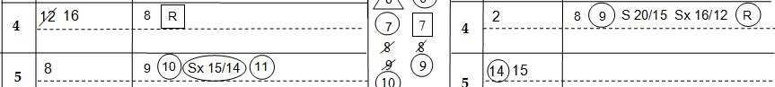



**Timeouts** are recorded in the boxes at the bottom of the running score column. The score of the team granted the timeout is recorded first, followed by the opposing team’s score.

Team A Team B

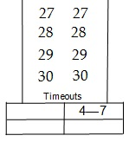 Team B was granted a timeout at 4 points. Team A’s score was 7.

The **SANCTIONS** section:

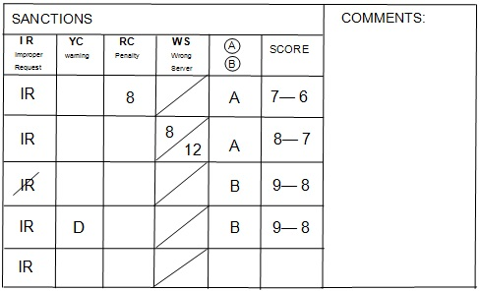

Improper Requests – slash the IR, record the team and the score. The score of the team that received the IR (Team B in this example) is recorded first.

Team Delay or Individual Warning (yellow card) – record a **D** for delay or the player’s number for an individual sanction. For the coach, use the letter **C** and for the assistant coach, use **AC**. In the example above, Team B received a yellow card warning for a delay of game with a score of 9 and Team A’s score was 8.

Team Delay or Individual Penalty (red card) – record a **D** for delay or the player’s number for an individual sanction. For the coach, use the letter **C** and for the assistant coach, use **AC**. In the example above, Team A’s #8 received an individual red card with a score of 7 and Team B’s score was 6.

The **Administrative Sanction** for illegal uniforms does not affect sanctions (individual or team). The administrative sanction is not recorded in the SANCTION section. The administrative sanction does not affect service order.

The Bulldogs received a sanction for white jerseys with white numbers outlined in black.

According to the Bulldog’s Coach, the team does not have legal jerseys available. The officials inform Bulldog’s Coach that Team B (Warriors) will start set one with a point.

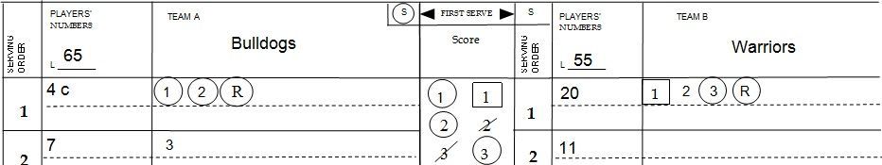

The Warriors received a sanction for jerseys with multi-color numbers. According to the Warriors’ Coach, the team does not have legal jerseys available. The officials inform the Warrior’s Coach that Team A (Bulldogs) will start set one with a point.

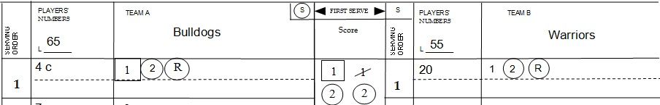

**Deciding Set Scoresheet**

Teams are required to switch sides at 8 (Men) or 13 points (Women) for the deciding set or for a one set playoff.

At the start of the deciding/playoff set, the team to the left of the scorer will finish the set on the right side of the scorer. The following information must be recorded on both sides (left and far right) of the scoresheet: The starting lineup, substitutions, timeouts, running score and the position when the libero serves (triangle).

At the start of the deciding set, the team’s information to the right of the scorer is recorded in the middle column of the scoresheet

When the teams switch sides, the last action recorded in the scoring section is carried from the left side of the scoresheet to the right side of the scoresheet.

For the remainder of the set, use the middle column for the team that is now on the scorer’s left and use the right column for the team now on the scorer’s right.

**Non-deciding set scoresheet**:

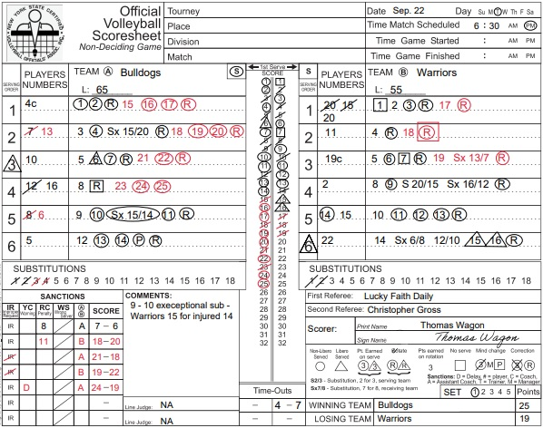

**Deciding set or one set playoff Scoresheet**:

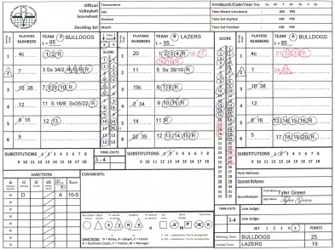

**The Assistant Scorer – Libero Tracking Sheet**

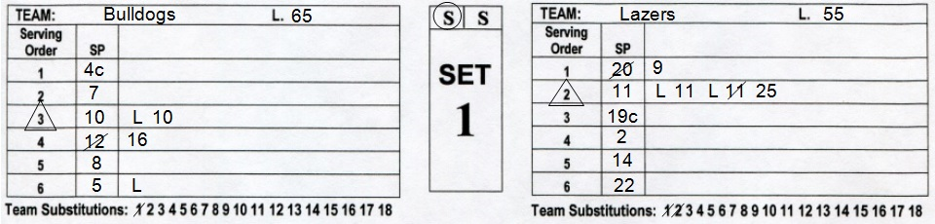

The starting players (**SP**) are recorded in serving order. The serving team will start with position one (right back) and the receiving team will start with position two (right front) on the lineup sheet.

Libero replacements do not count as substitutions.

The libero can only replace a back-row player.

Libero replacements are recorded by writing **L** beside the player’s number that was replaced. No slash is used for libero replacements.

When the libero leaves the court, the player replacing the libero must be the same player

the libero replaced. This is recorded by entering the player’s number beside the **L** on the tracking sheet.

There must be a completed rally between libero replacements, unless the libero is replacing the server. The libero can replace the server in one position in the serving order. The assistant scorer will place a triangle around the number in the **Serving Order** column the first time the libero serves.

When recording substitutions, write the player’s number entering the set next to the number of the player leaving the set. Slash the player’s number leaving the set as well as the next number in the Team Substitutions row.

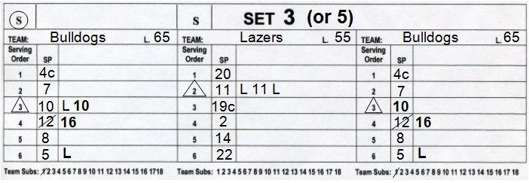

Use the deciding set (three column) at the bottom of the tracking sheet for the deciding set in a match or when there is a one set play-off.

When the deciding set tracking sheet is used, the team to the right of the scorer is recorded in the middle column. Replacements and substitutions are recorded only in the middle column for the team on the right.

The team to the left of the scorer is recorded on both the left and right columns this helps the assistant scorer when the teams switch courts. Before the teams change courts, for the team on the left, record libero replacements and substitutions in the far left column of the tracking sheet. Record the position where the libero serves and Team Substitutions both on the far left and far right of the tracking sheet.

When the teams change courts, move the final entry on each of the six lines from the far left (noted in bold) to the far right column. If the libero is on the court when the switch occurs, record the number of the player the libero replaced and write an L to the right of it.

For the remainder of the set, use the middle column for the team that is now on the scorer’s left and use the right column for the team now on the scorer’s right.

This manual does not take the place of the NCAA rules book. Rules that are not modified by the committees of NYSPHSAA are to be enforced according to the current rules guide and interpretations given at the annual NYSCVOA Rules Interpretation meeting.

This document was developed to act as a quick reference guide to the *New York State Rule Modifications* that have been approved by NYSPHSAA. To promote consistency across the state, all NYSCVOA officials should know the rules and procedures contained herein and adhere to them during all NYSPHSAA interscholastic volleyball competitions.

Service marked

This document cannot be reproduced without permission.

9/2011

Revised 8/2012; 8/14/12; 8/8/13; 8/19/2014; 7/22/2015

Revised 8/2016; 8/2017; 8/2018; 7/2019; 10/2020

**NYSCVOA Assignment Guidelines**

Below are the approved assignment practices. Assignments should be made using these guidelines whenever possible.

**Varsity rating** – Certified to be the first or second referee for the following level match:

Varsity, Junior Varsity, Modified

**Junior Varsity rating** – Certified to be the first or second referee for the following level match:

Junior Varsity, Modified

**Modified rating** – Certified to be the first or second referee for the following level match:

Modified

A **Junior Varsity** rated official may act as the second referee on Varsity contests.

A **Modified** rated official may act as the second referee on Varsity or Junior Varsity contests.

When the official roster is exhausted and matches cannot be covered using the above requirements, it is strongly recommended to check with the closest neighboring board for additional support.

Qualifying scores for Varsity, Junior Varsity and Modified ratings are identified in this document.

**New York State Certified Volleyball Officials’ Association**

**Ratings**

Varsity Minimum score on written exam 82

Minimum score on practical exam 85

Junior Minimum score on written exam 76

Varsity Minimum score on practical exam 75

Junior high Minimum score on written exam 70

Modified Minimum score on practical exam 65

Rating term Three years - from July 1 to June 30.

New/Transfer official – rating becomes effective upon completion of

Certification Procedure

Recertification Renewal, upgrade or downgrade of a rating is done prior to the expiration

of the current rating

Transfers Junior Varsity and Varsity ratings are transferable upon completion of the NYSCVOA Official Transfer form and notification of the new Chapter/Board. Members must be in good standing with their previous Board/Chapter in order to be eligible for transfer of a rating to a different Chapter/Board

* Local Chapters/Boards may stipulate requirements for transfer members

Instruction for Examinations

**Online**

Administration of the fifty question exam will be determined by the Exam committee annually and reviewed at the NYSCVOA Fall Meeting.

Officials will take the exam prior to the start of the officiating season.

When an official is renewing a rating, the practical exam may be administered before the written exam.

New officials must take the fifty question exam first.

An official is allowed only two attempts to pass the exam at the current/desired rating.

When an official is unable to pass the written exam(s), the official will be downgraded to the score received. Prompt notification of the assignor and Chapter leadership is essential.

**Practical**

Court evaluations are required initially and during the third year of a rating term.

* Must be done prior to the expiration of the current rating
* Local board/chapter policy may stipulate a one or two year rating term

The contest must be commensurate with the level of current rating or desired rating.

Court evaluations may be done in a different Board’s/Chapter’s territory from the candidate’s/official’s home board.

Evaluations may take place on one or more sets/matches

* All raters’ scores must average to the desired or current rating score
* A rater may not rate the same individual twice

**Varsity** level officials require 3 raters, two of which must have a current varsity rating

**Junior Varsity** officials require 2 raters, one of which must have a current varsity rating

**Junior high/Modified** officials require 2 raters; both must have a current varsity or junior varsity rating

**Three Practical Rating Options are Available**

The Numbered Practical Rating option:

The first/second referee is tested in seven domains as depicted on the position-specific rating sheet. At least one set must be observed for each position (R1/R2). If a situation is not observed, have the candidate reference rule(s) to a given example as a way of testing the skill. Quiz the official on non-observed set/match situations.

The Pass / Fail Practical Rating option:

The first/second referee is tested in four domains as depicted on the position-specific rating sheet. At least one set must be observed for each position (R1/R2).

Alternate Certification Practical Rating option:

The official must have held a Varsity Rating for more than 4 (four) consecutive years with the same (home) Chapter/Board.

The official must work a minimum of four (4) Varsity matches as the first referee during which seven (7) different raters are involved, and four (4) Varsity matches as the second referee with seven (7) different raters.

* The raters may be experienced coaches and or certified officials.

Certifying cards should be handed out to each rater prior to the contest. After the contest, the person responding should complete the card and return it to the local board’s designee.

Based on six (6) out of seven (7) certification cards, nothing can be lower than a three (3). If there is a score lower than a three (3), it is strongly recommended the official be observed using a different certification method cited above.

**Rating Option Criteria**

First year (new) and officials that are upgrading are restricted to the Numbered Practical Rating option only. The rating sheets must be signed by the candidate.

Veteran officials that have been a member in good standing with the same (home) Chapter/Board 4 (four) consecutive years or less can use the Pass/Fail Rating option. This option is restricted for officials maintaining a current rating. When using this option, one of the raters may be working the contest with the candidate that is being rated. The rating sheets must be signed by the candidate.

* Varsity officials renewing/maintaining current rating may have one varsity rater working the contest/set being used for the evaluation.

Veteran officials that have been a member in good standing with the same (home) Chapter/Board for more than 4 (four) consecutive years can use the Pass/Fail option or the Alternate Certification Procedure.

Practical ratings **must** be completed prior to the expiration of the current rating. No official can work a contest without a valid/current rating on file. Practical ratings must be completed within the same season the rating is due to expire.

* Officials that are rated in 2019. The rating is due to expire June 30th 2022. Therefore, the official must have a valid rating during the 2021-2022 season.
* Local board/chapter policy may stipulate a one or two year rating term

**When a Board/Chapter is required to have a State Clinic visit, rating sheets/cards may be requested for audit to ensure certification procedures are being followed correctly. Rating sheets/cards may be requested by the NYSCVOA leadership at any time.**

**There is no other approved certification (written or practical) procedure recognized by the New York State Certified Volleyball Officials’ Association.**

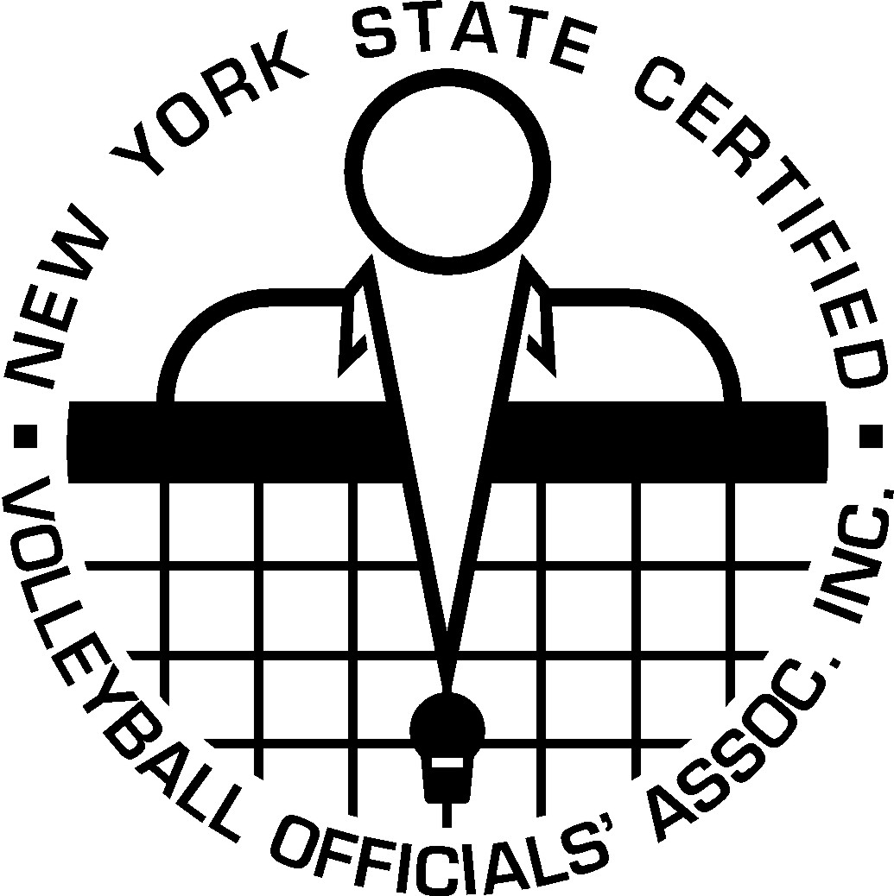 **New York State Certified Volleyball Officials’ Association**

**Official Transfer Form**

The current Board Chair will communicate in writing to the new Board Chair validating the status of the member requesting a transfer. The current Board Chair will keep a copy of all communications sent to the new Board Chair. The communications must be dated.

The “transfer” official must adhere to the (new) local Chapter’s/Board’s Constitution, By-Laws any operating codes and procedures in relation to the transfer of membership.

Date form completed / sent ___________ Date completed form received __________

Official’s current name/address: Future name/address:

___________________________ _________________________

___________________________ _________________________

Phone #____________________ Phone #_______________________

E-Mail _____________________ E-Mail ________________________

Current Board Chair’s contact information: _________________________

_____________________________________________________________

Member in-good-standing (circle) yes no comments_______________

____________________________________________________________

Last completed online test score: Date taken ______ Score______

Last completed practical test score: Date taken ______ Score______

Practical testing method: (circle) Numbered Pass/Fail Certification Cards

11/2012; revised 8/2013; 7/2015

Reviewed 7/2016; 7/2018; 11/2020