[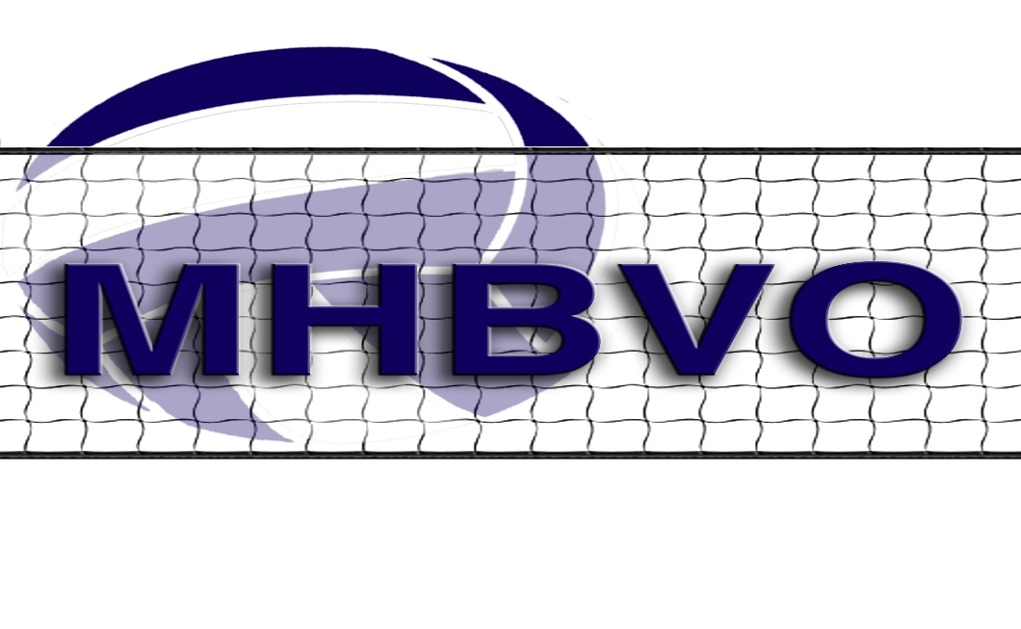](http://www.mhbvo.org/wp-content/uploads/2015/11/LogoSeven.jpg)

RE: Meeting 8/19/20

Committee Report: Sportsmanship

Summary of 2019 Winners

Orange County Cornwall Average Vote 5.29 15 Votes

Dutchess County Pine Plains Average Vote 4.87 10 Votes

Ulster County Onteora Average Vote 4.74 16 Votes

The highest number of votes received for any one school were 23 votes!

We have close to 60 Officials; we really need much better participation!

It was suggested that we present the Sportsmanship award at Senior Night for the winning school.

This could be done but it would require much more participation from all Officials. Votes would need to be sent in weekly for the first 6 weeks of the season. If we could determine a winner at that time it could be presented at Senior Night.

In the upcoming season (whenever that is) I will be sending out weekly e-mail reminders! If we get the participation, we need we could move forward with this.

Committee Report: Contracts

Nothing new to report on any Contracts

Wayne Vetro