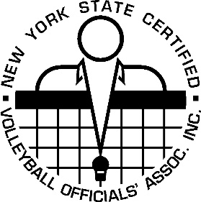 NYSCVOA

NEWSLETTER #1

September 1, 2019

**Uniform Rule NCAA RULEBOOK 7.1.2.4**

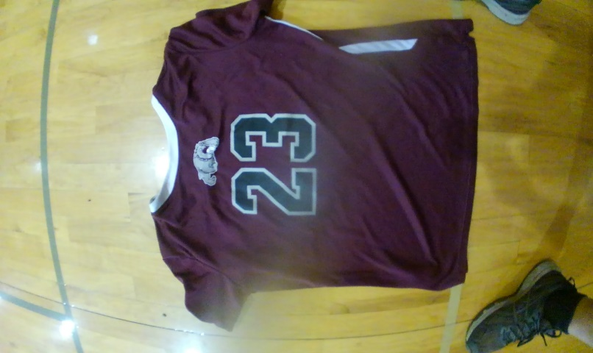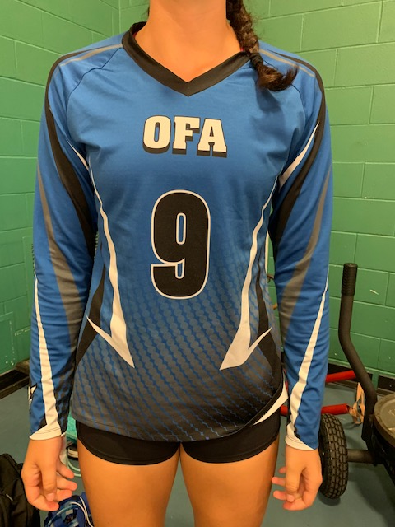

**The Jersey number must be of a color that is clearly in distinct contrast with the color of the jersey, irrespective of the boarder around the number.**

**NOT LEGAL LEGAL**

The number is this picture, is not a distinct The number in this

contrast with the color of the jersey. picture is definitely a

If there were no border around the number distinct contrast to the

the number would not be clear. color of the jersey.

**Page 1**

**GIRLS ONLY PRE-MATCH PROTOCOL**

**(STEP BY STEP)**

* After the 1 minute horn sounds, make sure the auto horn is turned off.
* The clock continues to run.
* Get the teams on their respective end lines.
* Start introductions, national anthem.
* The R1 will be on the side of the net with the official's stand.
* The R2 will be on the opposite side of the net
* Both the R1 and R2 will stand on the sideline (between the attack line and the net).
* If you are facing the court from the scorer's table, the R2 will be on the right side of the net, the R1 will be on the left side of the net.
* After introductions, national anthem, etc..., the R1 will whistle (use the end of match signal) and the teams will conduct the pre-match handshake.
* The teams will return to their respective coaches for a **brief** period of time and then immediately take the court.
* The R2 will do a lineup check, authorize libero's entry (if applicable) release the game ball and play will begin.
* **If there are no introductions, national anthem, etc..., conduct the pre-match handshake as described above and continue the same protocol.**

**Page 2**

**Rule Clarifications**

**#1 Insulin pump/regulator/pod**

**These are legal. NYSPHSAA states:**

If the device will work properly covered, then cover the device, if it poses a safety concern. If the device can't be covered because it won't function correctly, then it may remain uncovered. If there is a question about player safety and the device can't be covered, have the coach/AD request a waiver from NYSPHSAA (Todd Nelson).

**#2 Plastic spacers in ears**

**These are NOT legal. NYSPHSAA states:**

All jewelry must be removed and this includes any plastic/rubber inserts that take the place of jewelry.

**#3 Electronic scoring**

**Legal.**

But according to the rules book it is strongly encouraged to have a back-up paper copy.  
NCAA page 6 #2.